A.S.R.C.C. Preorder Phase 2 open from 1 July to 20 August 2026 for the:
“C4703PY Holden A9X Torana - 2026 A.S.R.C.C - Yellow”

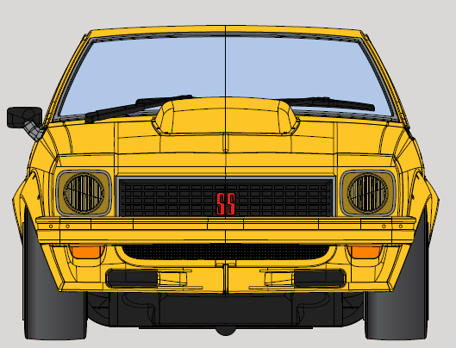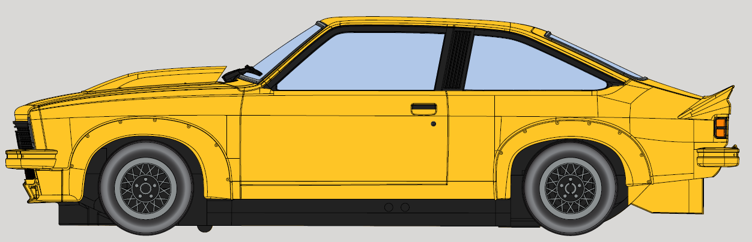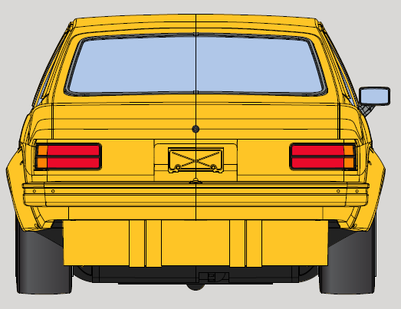

Template with Details to Lodge Your Membership’s Pre-order Phase 2:
Below is the pre-order form for Phase 2. Please note the format has changed and there are three sections for a response noting one is only applicable if you are have a Family or Business Membership. It is only 1 car per Member.
If oversubscribed, Members yet to pre-order given priority with a ballot used.

Preorder C4703PY Holden A9X Torana - 2026 A.S.R.C.C – Yellow. $99 each.
- Please either send this back to the Club or email with required information.
- This form is added to the Club website from 7th July to help use in an email.
- Please note pre-orders close on Thursday 20/8/26.
- There are 3 sections for response for your Membership pre-order:
1. Primary Member request to pre-order one C4703PY Torana A.S.R.C.C.:
Primary Member Name _________________, Mem Number ____. Quantity 1.

2. Family or Business secondary Members pre-order one car each:
Secondary Member Name _______________, Mem Number ____. Quantity 1.
Secondary Member Name _______________, Mem Number ____. Quantity 1.
Secondary Member Name _______________, Mem Number ____. Quantity 1.

3. Request a specific Car number and understand it is not guaranteed _____.

Important Note - It is one pre-order form per Membership - Single, Family or Business.
- A Primary Member in a Single Membership is the Member. In a Family or Business Membership it is the person to whom Club Lines is addressed to.
- Secondary Member describes all other Members in a Family or Business Membership.

Please email your pre-orders to both: roger@scalextricaustralia.com and
dominic@scalextricaustralia.com
Or send completed form to: ASRCC 2026 Car, PO Box 4276, Pitt Town, NSW, 2756.

For any queries, please contact the two Committee Members noted above.
Cheers Dominic and the Club Committee

